5.1. POWER SUPPLY
Definition:
A power supply (sometimes known as a power supply unit or PSU) is a device or system that supplies electrical or other types of energy to an output load or group of loads. The term is most commonly applied to electrical energy supplies, less often to mechanical ones, and rarely to others.
5.1.1. POWER SUPPLY UNIT BLOCK
All digital circuits work only with low DC voltage. A power supply unit is required to provide the appropriate voltage supply. This unit consists of transformer, rectifier, filter and a regulator. AC voltage typically of 230Vrms is connected to a transformer which steps that AC voltage down to the desired AC voltage level. A diode rectifier then provides a full wave rectified voltage that is initially filtered by a simple capacitor filter to produce a DC voltage. This resulting DC voltage usually has some ripple or AC voltage variations. Regulator circuit can use this DC input to provide DC voltage that not only has much less ripple voltage but also remains in the same DC value, even when the DC voltage varies, or the load connected to the output DC voltage changes. The required DC supply is obtained from the available AC supply after rectification, filtration and regulation. Block diagram of power supply unit is shown in Figure 2.1
AC SUPPLY
TRANSFORMER
RECTIFIER
FILTER
VOLTAGE
REGULATOR
DC SUPPLY

Figure 5.1 Power Supply Block Diagram
The main components used in the power supply unit are Transformer, Rectifier, Filter and Regulator. The 230V AC supply is converted into 9V AC supply through the transformer. The output of the transformer has the same frequency as in the input AC power. This AC power is converted into DC power through diodes. Here the bridge diode is used to convert AC supply to the DC power supply. This converted DC power supply has the ripple content and for normal operation of the circuit, the ripple content of the DC power supply should be as low as possible. Because the ripple content of the power supply will reduce the life of the circuit. So to reduce the ripple content of the DC power supply, the large value of capacitance filter is used.
This filtered output will not be the regulated voltage. For this purpose IC7805 regulator IC is used in the circuit.
TRANSFORMER
Transformer is a device used either for stepping-up or stepping-down the AC supply voltage with a corresponding decreases or increases in the current. Here, a transformer is used for stepping-down the voltage so as to get a voltage that can be regulated to get a constant 5V.
RECTIFIER
A rectifier is a device like semiconductor, capable of converting sinusoidal input waveform units into a unidirectional waveform, with a nonzero average component.
FILTERS
Capacitors are used as filters in the power supply unit. The action of the system depends upon the fact, that the capacitors stores energy during the conduction period and delivers this energy to the load during the inverse or non-conducting period. In this way, time during which the current passes through the load is prolonged and ripple is considerably reduced.
VOLTAGE REGULATOR
The LM78XX is three terminal regulator available with several fixed output voltages making them useful in a wide range of applications. IC7805 is a fixed voltage regulators used in this circuit.
Circuit diagram of such power supply is as shown in Figure 3.2
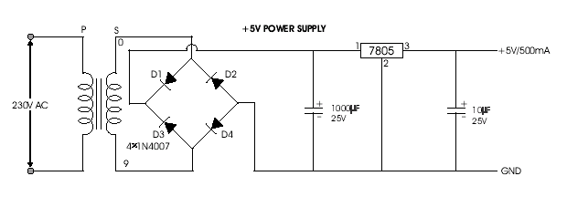
Figure 5.1.1 Five Volts Power Supply

